GIT

Git is distributed version control system

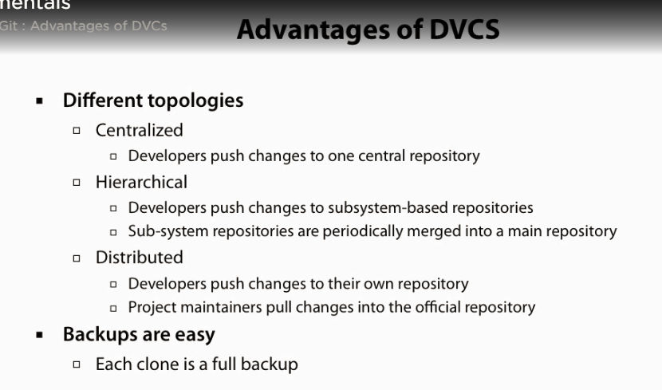

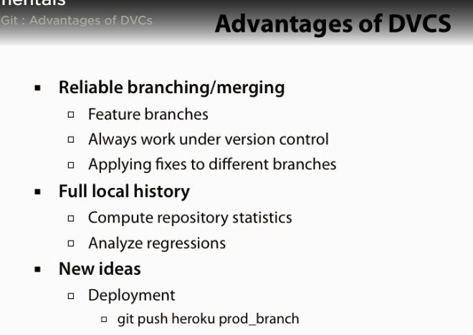

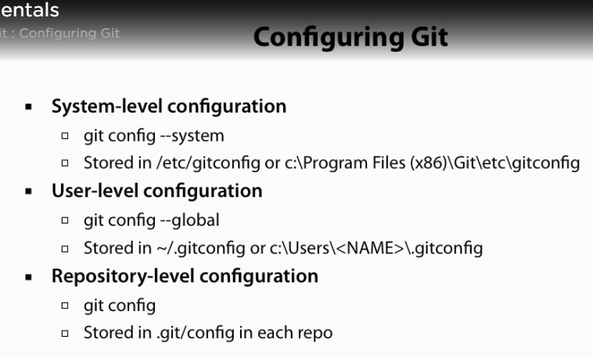

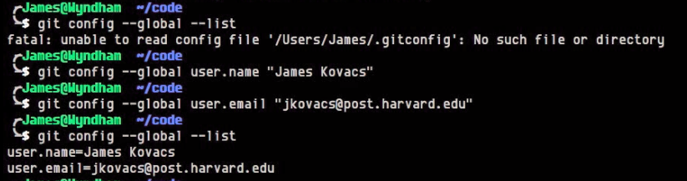

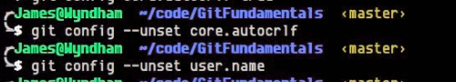

Working Locally With Git

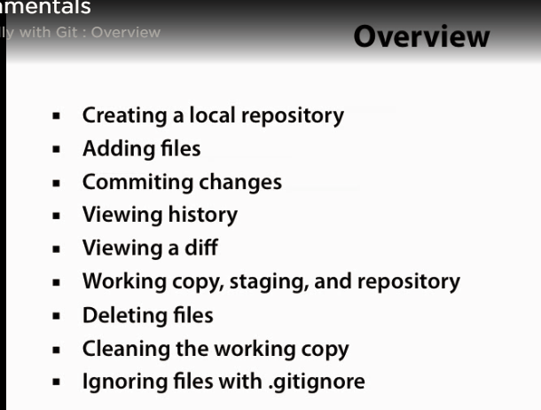

Git init – It will create .git file in project folder.

GIT status- list all changes done in project folder i.e add/update/delete files

Git add <File name to be added in tracking by git>

Git commit – commit files to staging area

Git log- show logs of git project and all commit history

Git add -u – this will add updated files to be consider for git commit,

Git commit -m<commit message>

Git diff HEAD~[1-means I commit back to head]..HEAD this with show difference in HEAD/latest commit with previous/Head-1.

Git add -a this add all untracked files

Git checkout <file name> -If we have modified any file locally but we want to restore file from repository

Git reset –hard – this will discard all local changes and restore all locally modified files.

Git reset –soft HEAD~1 this will restore local copy with HEAD-1 version of commit, this may be useful to revert changes. First get changes locally and then commit again.

Git clean this will remove any unrequired files from working local copy

.gitignore we can add folder and files in this file which needs to be ignored by git while recognizing for tracking. All folders and files have relative path to project directory.

Working remotely with GIT

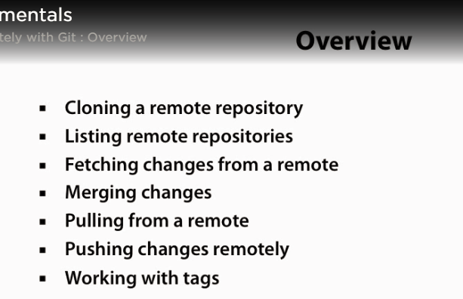

GIT Clone <URL of repository>

Git log –oneline : to display commit history in 1 line per commit

Git log –oneline | WC -l : to diplay all commits count

Git log –oneline –graph : to list all branches and merges

Git shortlog -sne

Git remote -v

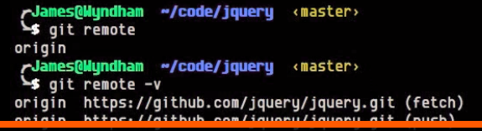

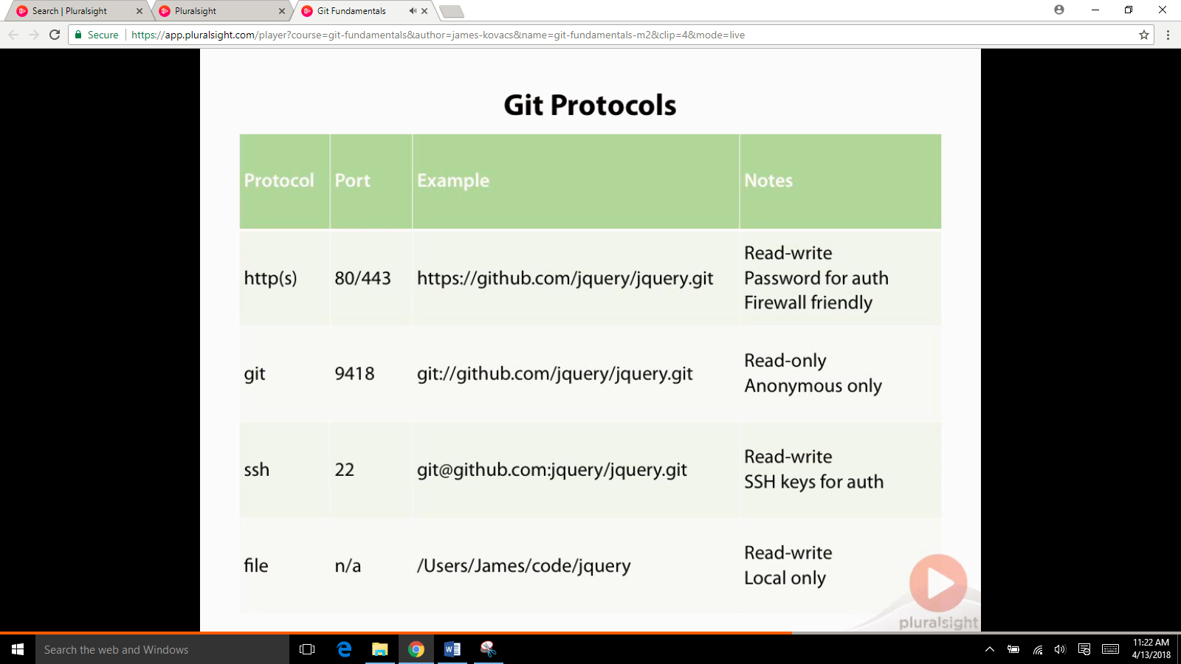

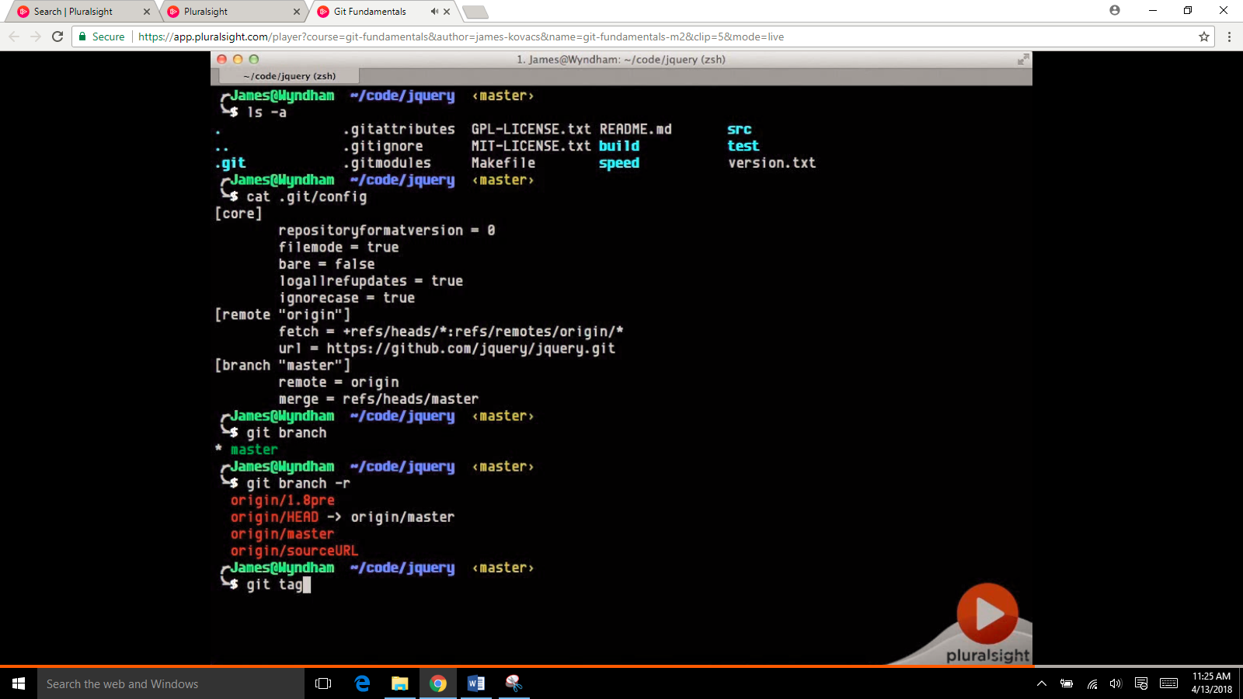

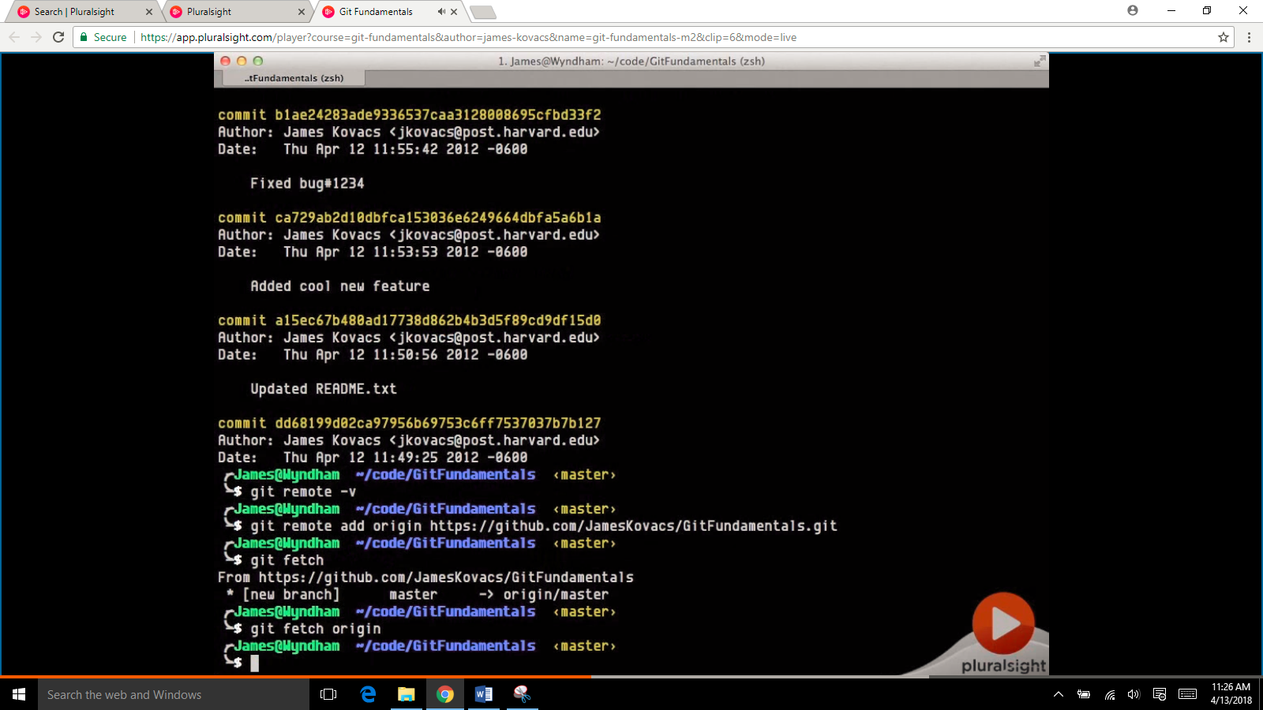

Git log origin/master

But data is still not in local folder from origin

Git merge origin/master :this will merge repository changes to local master repository

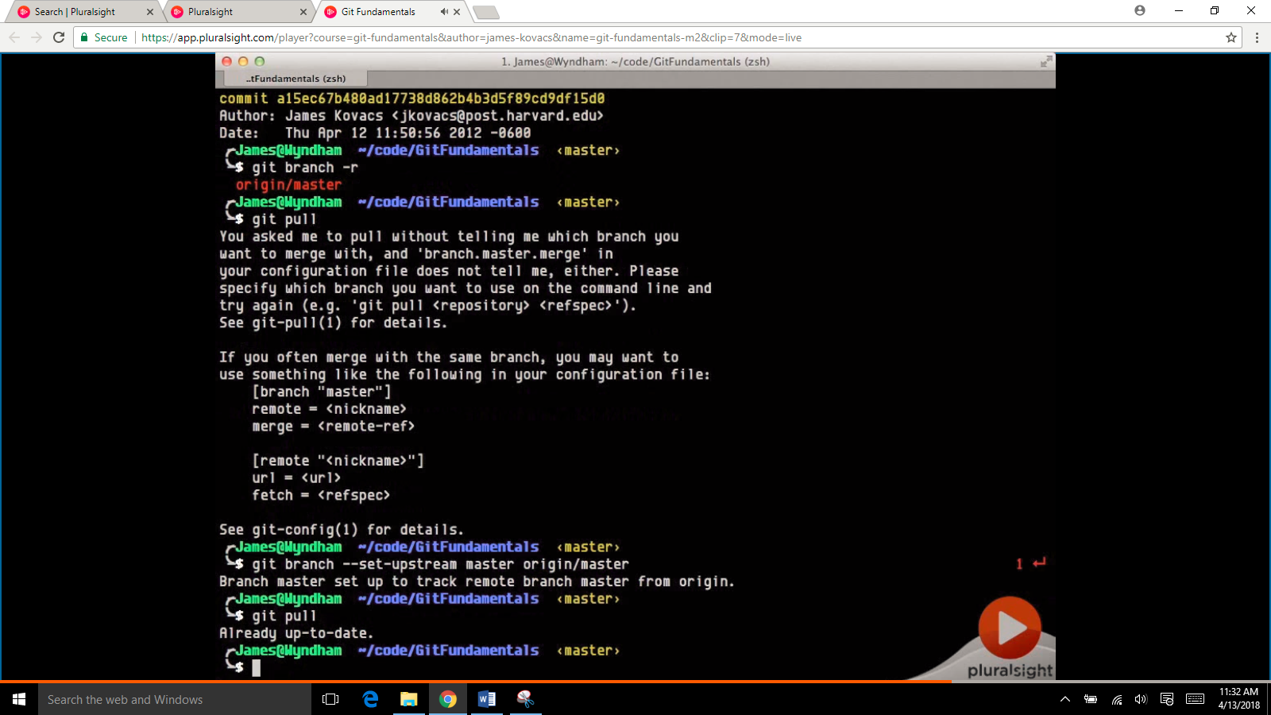

Modify any local file and check git status

Then do git commit and again check git status, status will tell that nothing more to commit but will also tell my branch is ahead of 1 commit which I wil need to merge to remote repository.

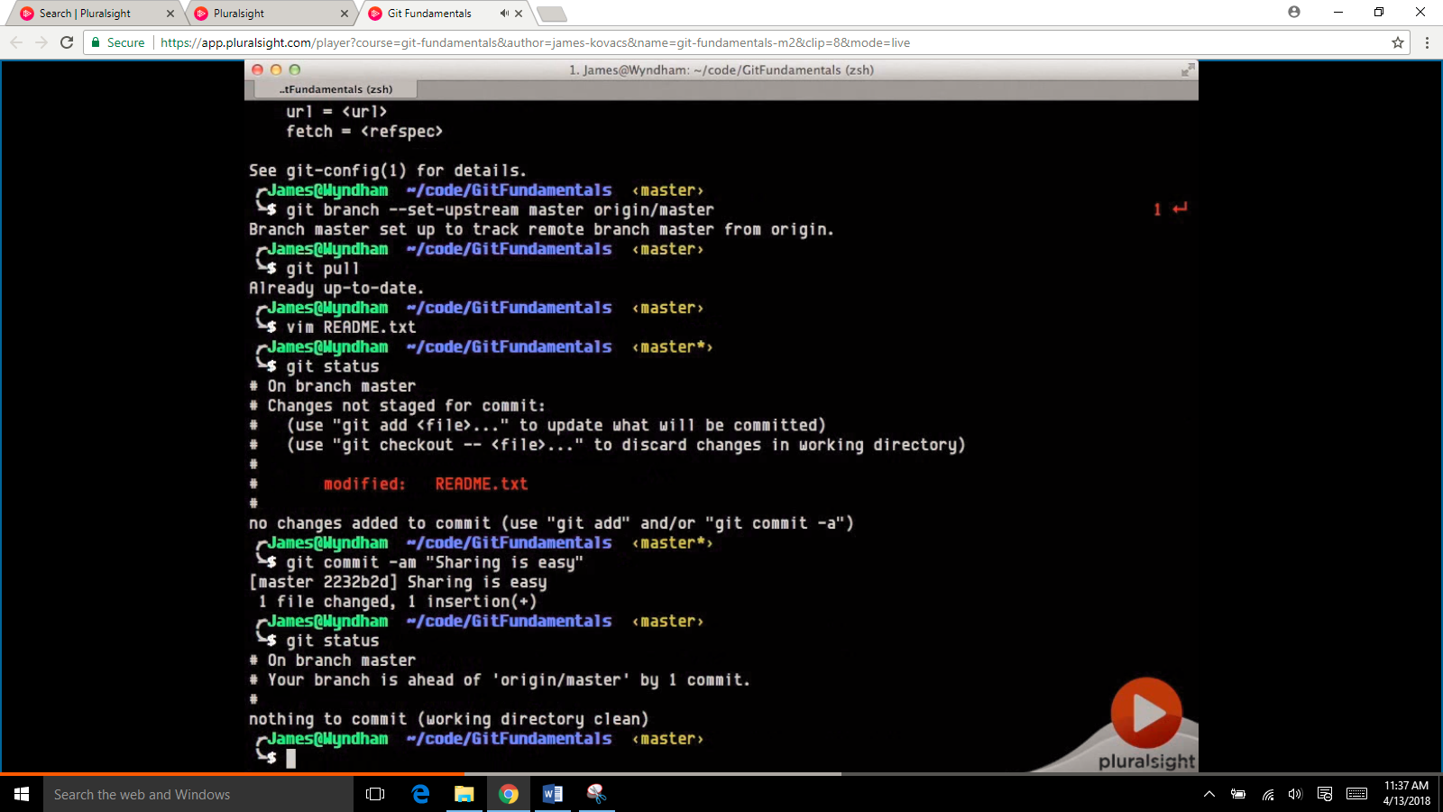

Now do git push, it will ask username and password, alternately we can use SSH and use ssh key.

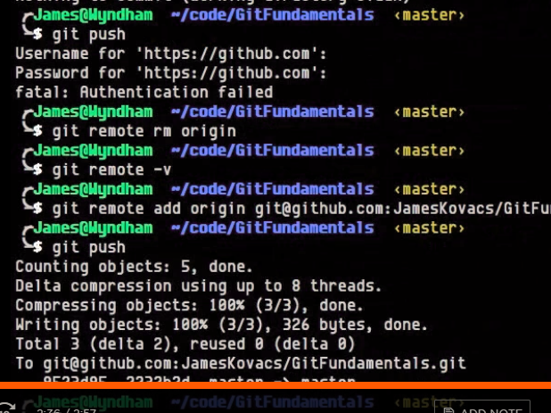

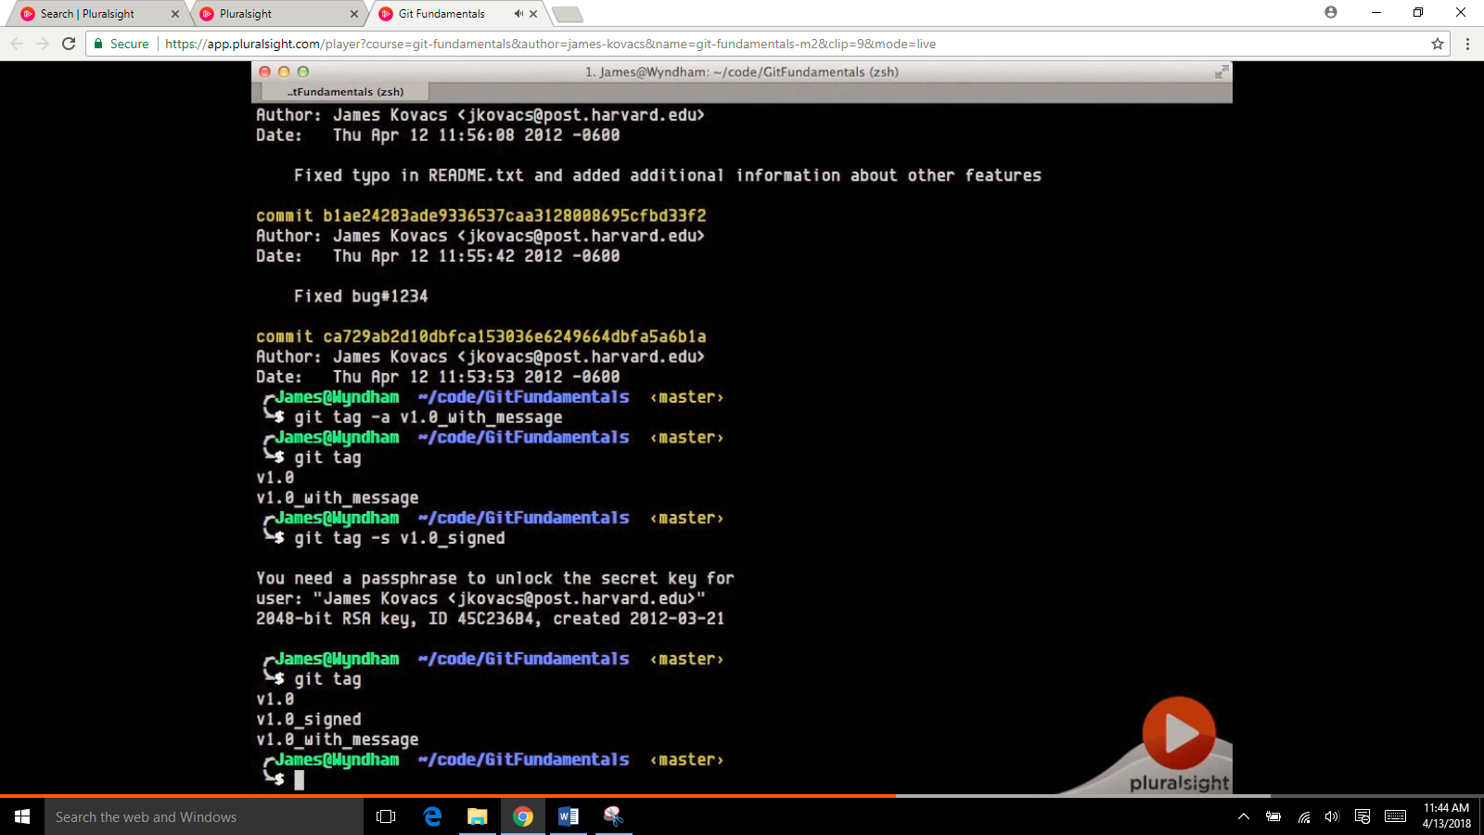

Git push –tags : this will push local repository tags to remote

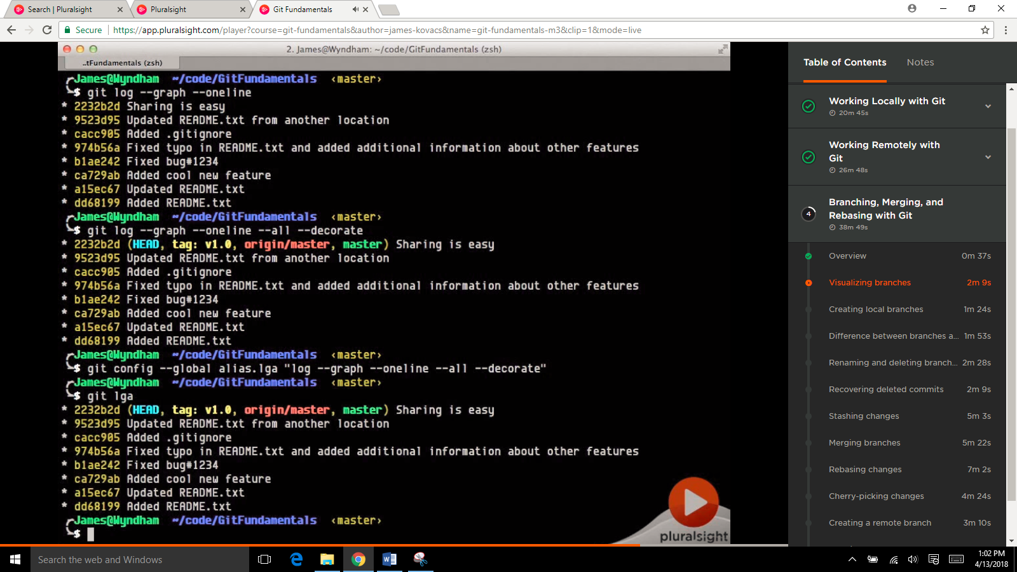

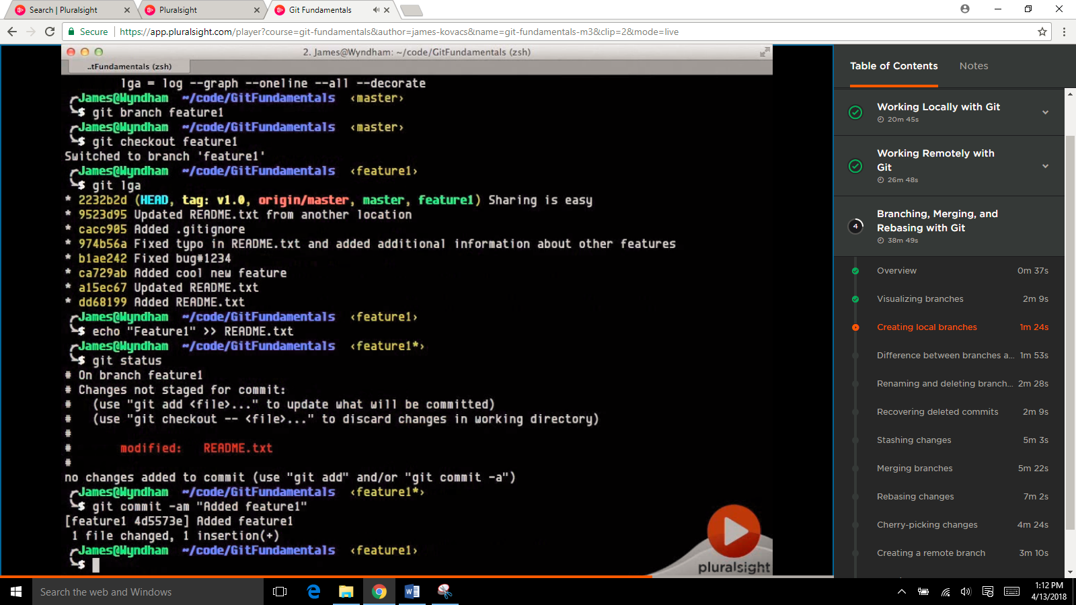

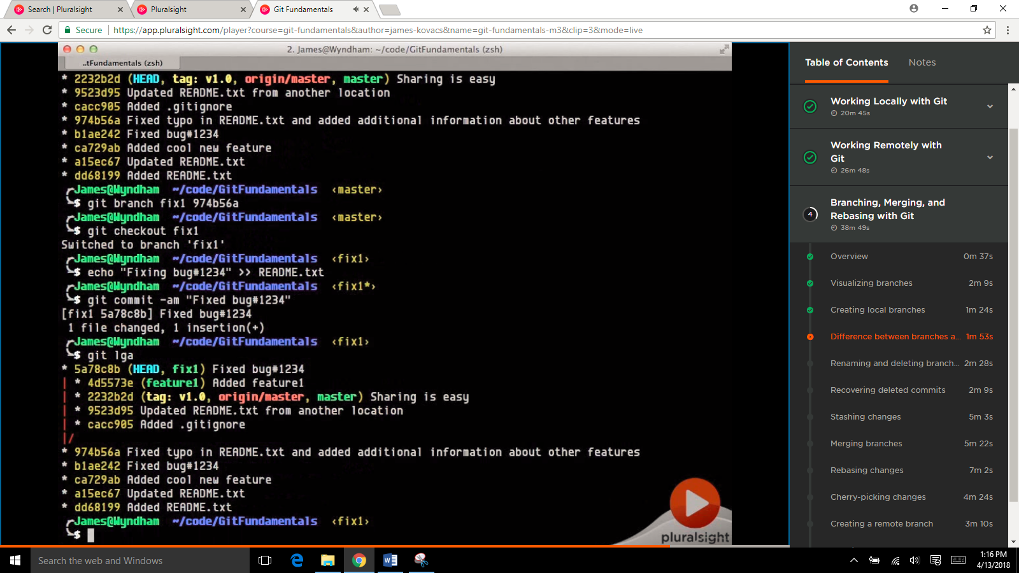

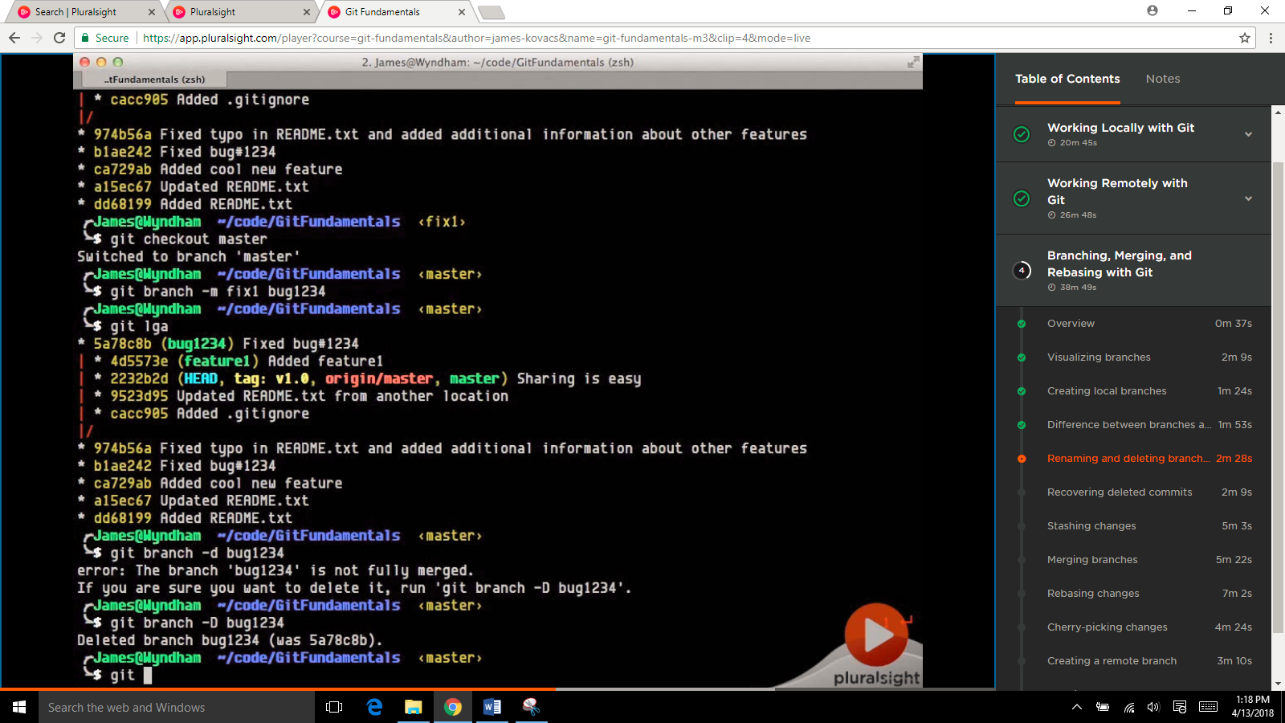

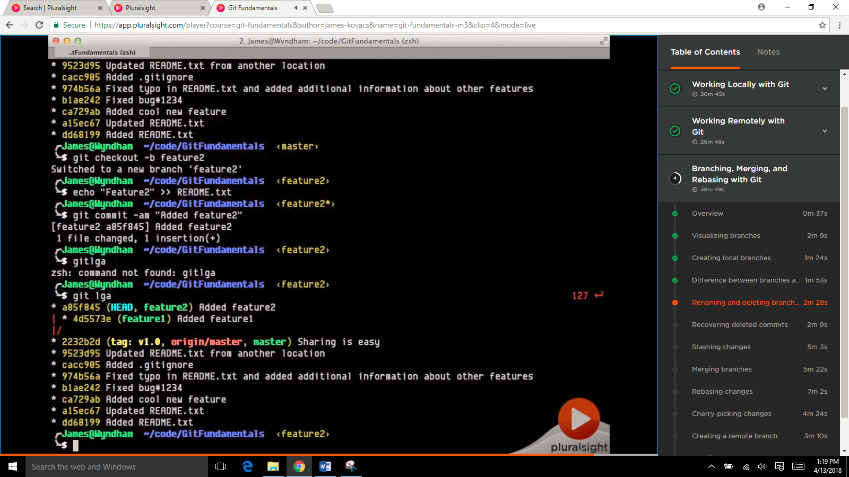

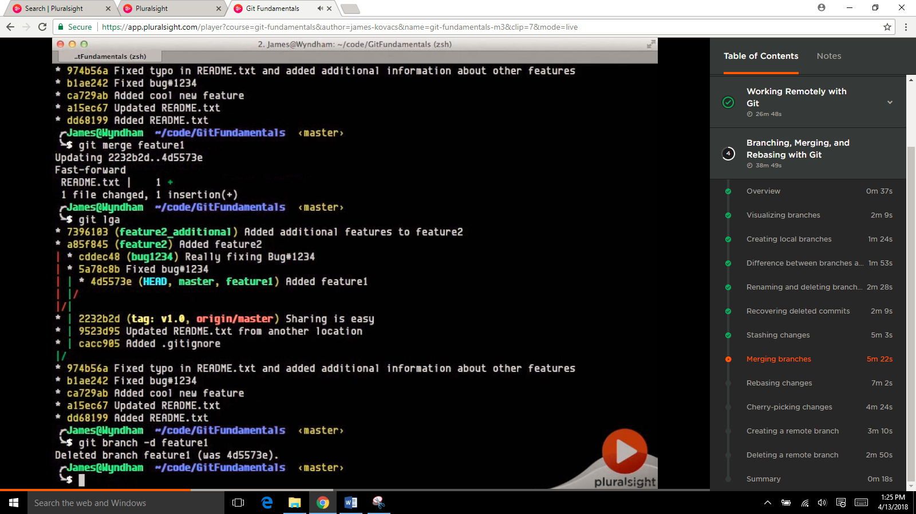

Discard all local changes and take updates from server

git fetch --all

git reset --hard origin/master

delete remote branch

git push origin –delete {branch}